**COMPUTER NETWORKS**

**NAME: M.ISTAFA MALIK**

**ROLL: P190033**

**SECTION: BSCS-5A**

TASK 1:

1. Is your browser running HTTP version 1.0, 1.1, or 2?

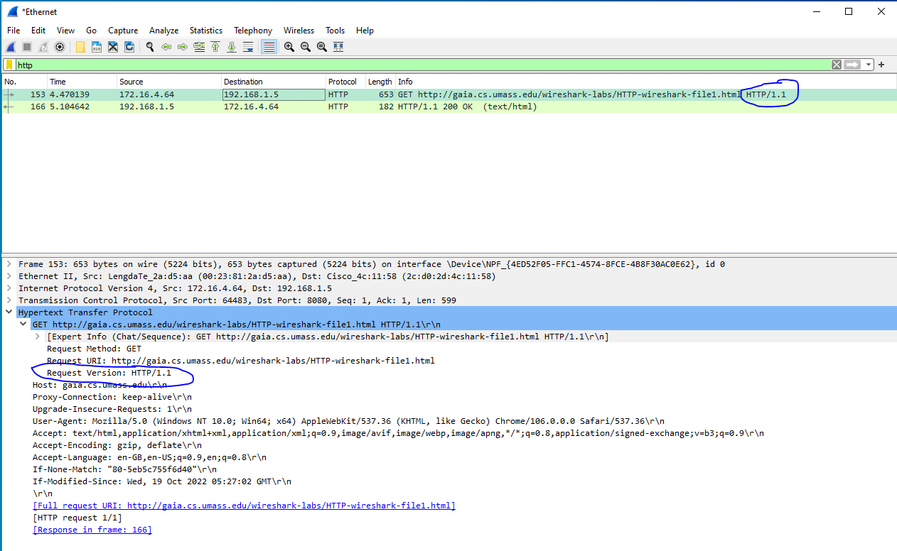

The Version here is 1.1, you can see that in hypertext transfer protocol.

1. What version of HTTP is the server running?

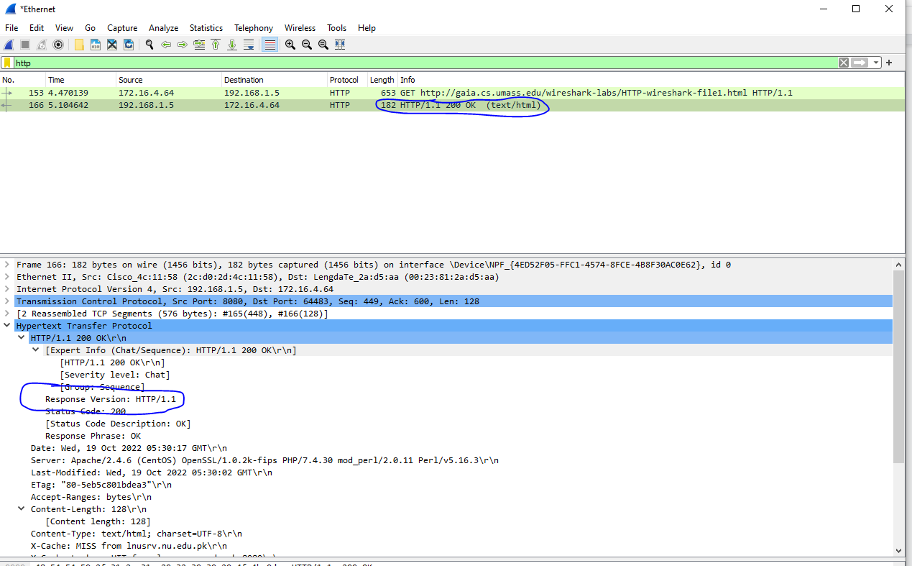

The Version here is also 1.1, you can see that in hypertext transfer protocol .

1. What languages (if any) does your browser indicate that it can accept to the server?

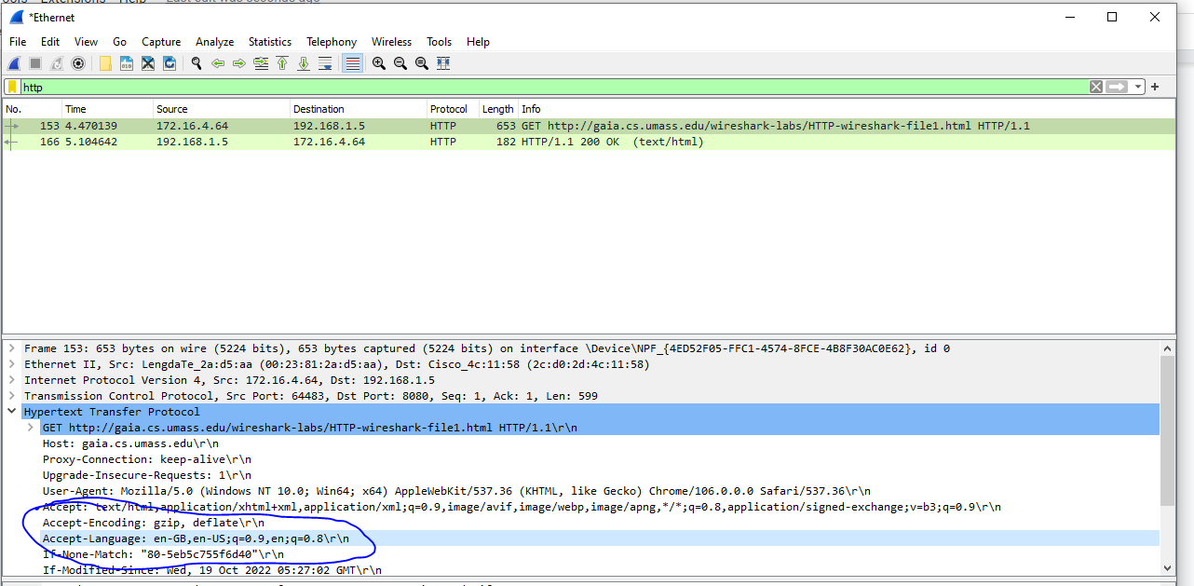

The Language use here is English (Great Britain) and English (US).

1. What is the IP address of your computer? What is the IP address of the gaia.cs.umass.edu server?

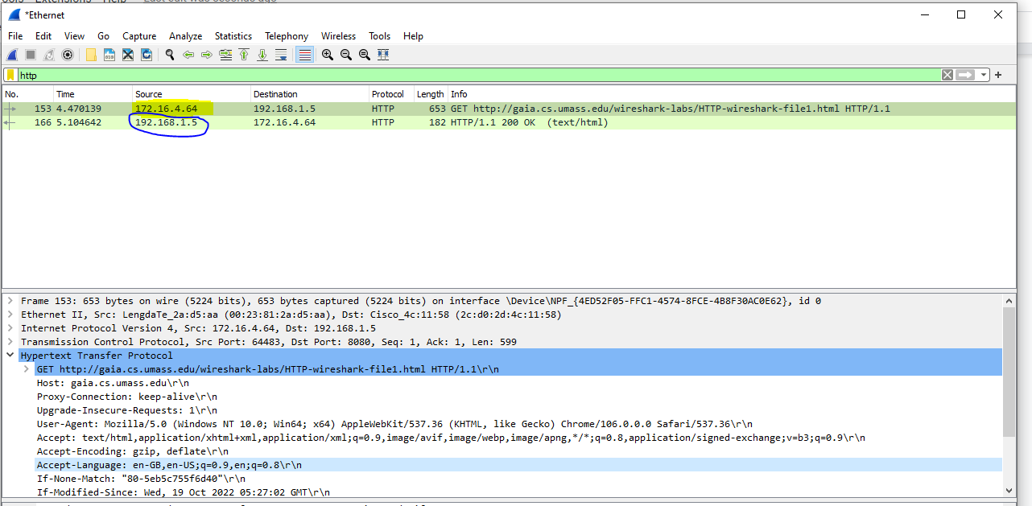

The Highlighted IP address is my IP Address while the encircled in blue is the server.

1. What is the status code returned from the server to your browser?

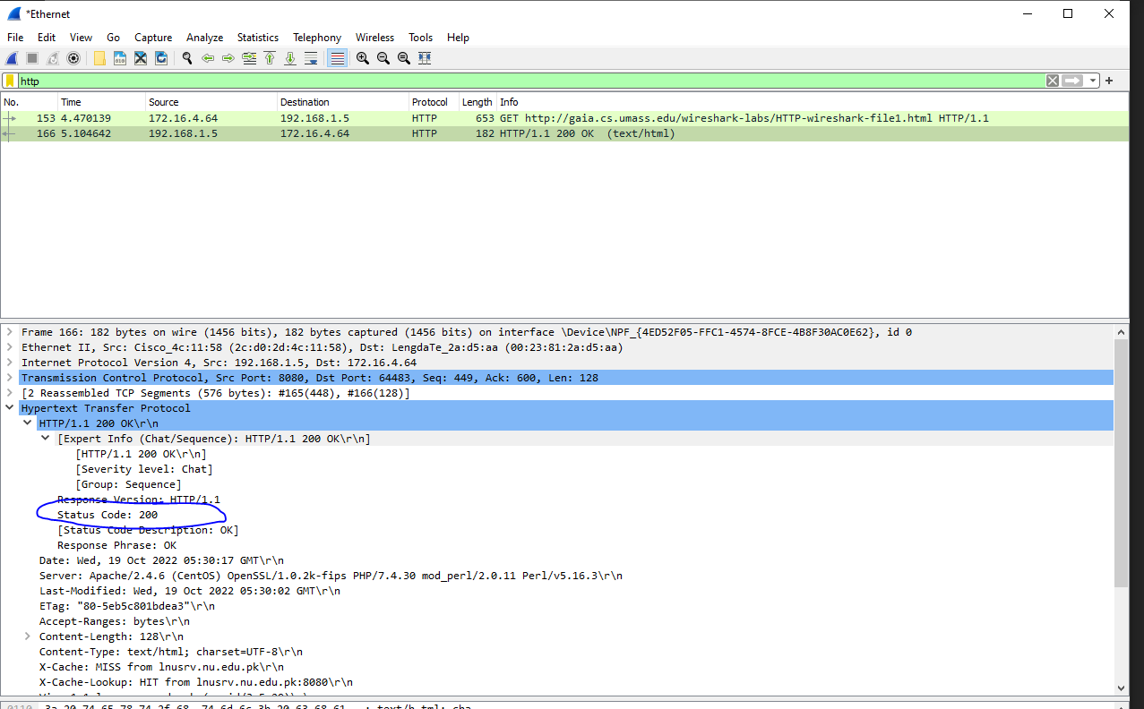

The code returned is 200 (encircled in blue).

1. When was the HTML file that you are retrieving last modified at the server?

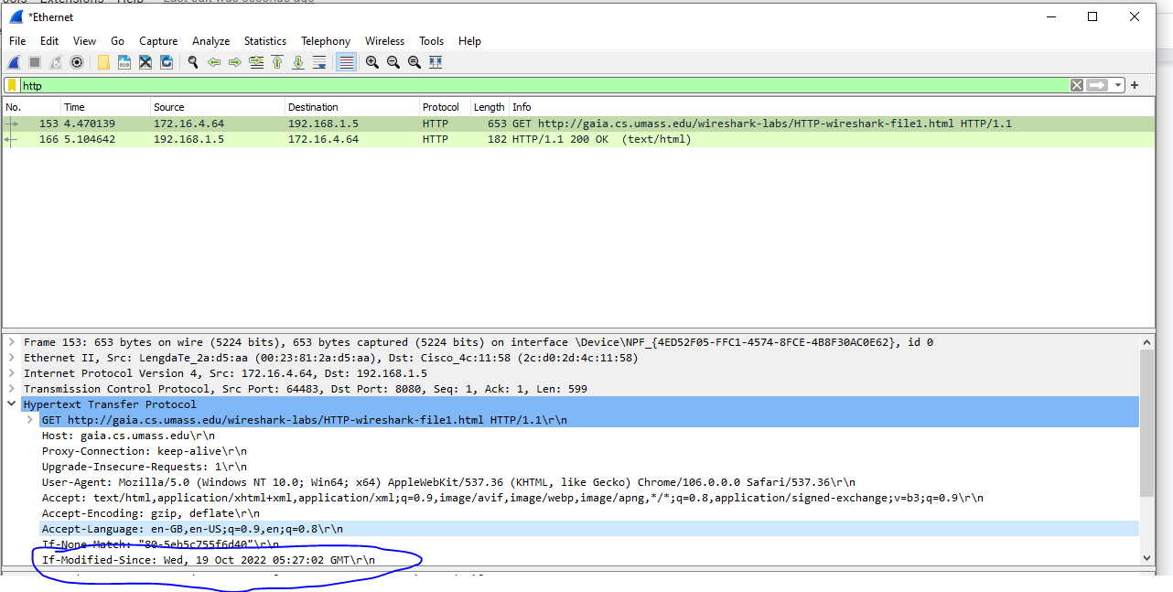

The date is encircled in blue which is Last modified was Wednesday, 15 Oct, 2022.

1. How many bytes of content are being returned to your browser?

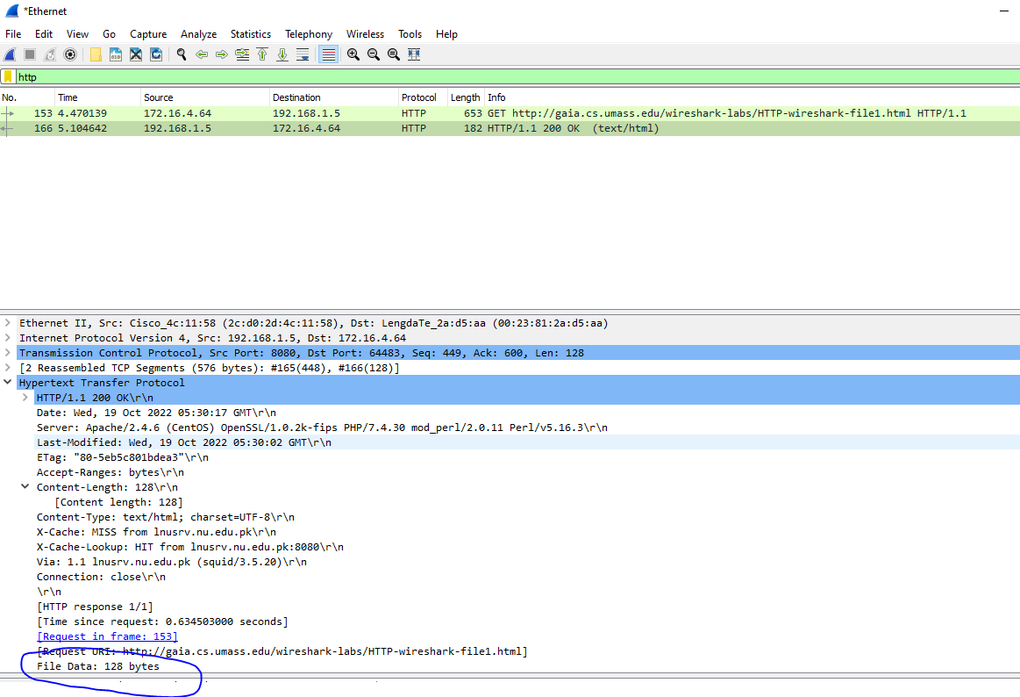

The size is 128 bytes which is encircled in blue.

**Task:**

1. Inspect the contents of the first HTTP GET request from your browser to the server. Do you see an “IF-MODIFIED-SINCE” line in the HTTP GET?

No there is no IF-MODIFIED line in the HTTP GET.

1. Inspect the contents of the server response. Did the server explicitly return the contents of the file? How can you tell?

The contents of the file were expressly returned by the server. The "Line-Based Text Data" part of Wireshark displays what the server delivered back to my browser, more specifically, what the website displayed when I opened it up on my browser.\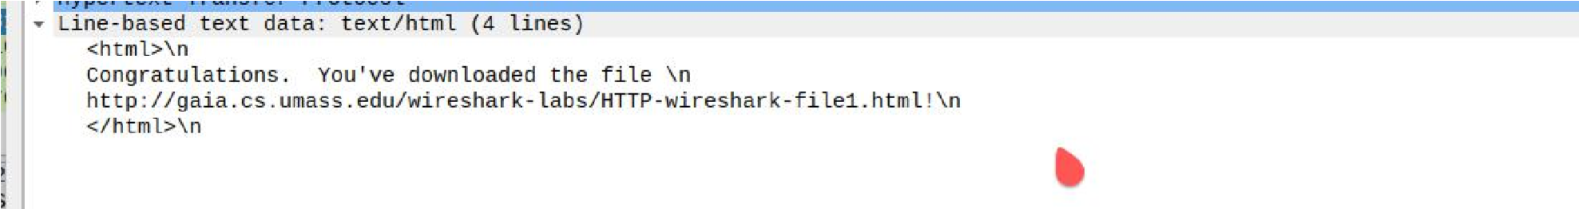

1. Now inspect the contents of the second HTTP GET request from your browser to the server. Do you see an “IF-MODIFIED-SINCE:” line in the HTTP GET6 ? If so, what information follows the “IF-MODIFIED-SINCE:” header?

Yes, there is an IF-MODIFIED-SINCE line in the second HTTP message. The time and date that I most recently accessed the website are listed below.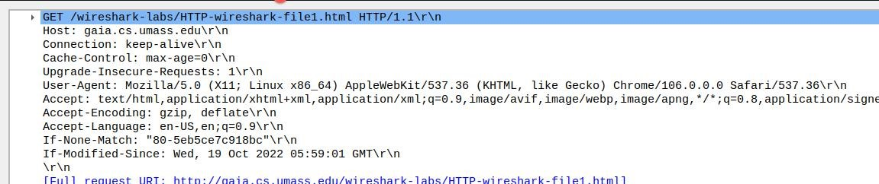

1. What is the HTTP status code and phrase returned from the server in response to this second HTTP GET? Did the server explicitly return the contents of the file? Explain.

The HTTP status code is “304: Not Modified”